# Lab: Lists Basics

This document defines the exercises for the ["Python Fundamentals" course at @Software University.](https://softuni.bg/trainings/4379/programming-fundamentals-with-python-january-2024)

Please submit your solutions (source code) to all the below-described problems in [Judge](https://judge.softuni.org/Contests/1724/Lists-Basics-Lab).

## Strange Zoo

*You are at the zoo, and the meerkats look strange.*

You will receive **3 strings** on separate lines, representing the **tail**, the **body**, and the **head** of an animal in that order. Your task is to **re-arrange** the elements **in a list** so that the animal looks normal again:

* On the **first position** is the **head**;
* On the **second position** is the **body**;
* On the **last one** is the **tail**.

### Example

|  |  |
| --- | --- |
| **Input** | **Output** |
| my tail  my body seems on place  my head is on the wrong end! | ['my head is on the wrong end!', 'my body seems on place', 'my tail'] |
| tail  body  head | ['head', 'body', 'tail'] |
| T  B  H | ['H', 'B', 'T'] |

### Hints

We start by reading the three parts of the body:

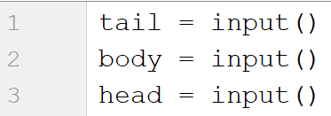

Then, we create a list containing those three elements:



We swap the elements and print the list:



## Courses

On the first line, you will receive a single number **n**. On the following **n** lines, you will receive **names** of courses. You should create a **list of courses and print it**.

### Example

|  |  |
| --- | --- |
| **Input** | **Output** |
| 2  PB Python  PF Python | ['PB Python', 'PF Python'] |
| 4  Front-End  C# Web  JS Core  Programming Fundamentals | ['Front-End', 'C# Web', 'JS Core', 'Programming Fundamentals'] |

### Hints

We read the number **n** from the console, and we create an **empty list**:

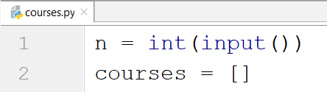

Then, we create a loop that reads each course and adds it to the list:

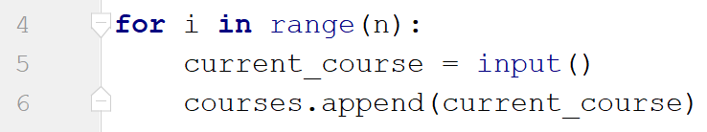

Finally, we print the list:



## List Statistics

On the first line, you will receive a number **n**. On the following **n** lines, you will receive integers. You should **create** and **print** two lists:

* One with all the positive (including 0) numbers
* One with all the negative numbers

Finally, print the following message:

**"Count of positives: {count_positives}**

**Sum of negatives: {sum_of_negatives}"**

### Example

|  |  |
| --- | --- |
| **Input** | **Output** |
| 5  10  3  2  -15  -4 | [10, 3, 2]  [-15, -4]  Count of positives: 3  Sum of negatives: -19 |
| 6  11  2  35  599  31  20 | [11, 2, 35, 599, 31, 20]  []  Count of positives: 6  Sum of negatives: 0 |

### Hints

We start by reading the number n:

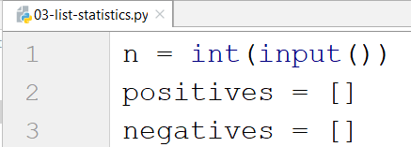

Then, we create **a loop** that reads the **current number** and checks if it **is positive or not**:

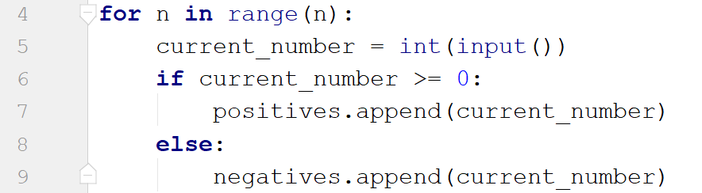

* If it is, we add it to the list of positive numbers.
* If it is not, we add it to the list of negative numbers.

Then we print the three lines:



* To get the count of the positives, we can use the **len** function.
* To get the sum of the negatives, we can use the **sum** function.

## Search

On the first line, you will receive a number **n**. On the second line, you will receive a word. On the following **n lines,** you will be given some **strings**. You should **add** them to a **list and print** them. After that, you should **filter out** only the strings that **include** the given **word** and **print** that list too.

### Example

|  |  |
| --- | --- |
| **Input** | **Output** |
| 3  SoftUni  I study at SoftUni  I walk to work  I learn Python at SoftUni | ["I study at SoftUni", "I walk to work", "I learn Python at SoftUni"]  ["I study at SoftUni", "I learn Python at SoftUni"] |
| 4  tomatoes  I love tomatoes  I can eat tomatoes forever  I don't like apples  Yesterday I ate two tomatoes | ["I love tomatoes", "I can eat tomatoes forever", "I don't like apples", "Yesterday I ate two tomatoes"]  ["I love tomatoes", "I can eat tomatoes forever", "Yesterday I ate two tomatoes"] |

### Hints

We start by reading the number n and the word we would search for. Then, we create our empty list:

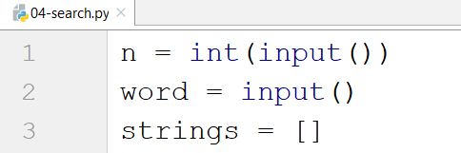

We create a loop that adds all the strings to our list. After that, we print it:

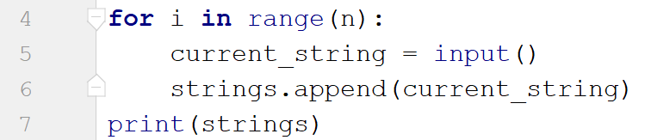

Finally, we create another loop to remove the strings we do not need by iterating through the strings reversed (so we don't skip elements when removing) and print the list again:

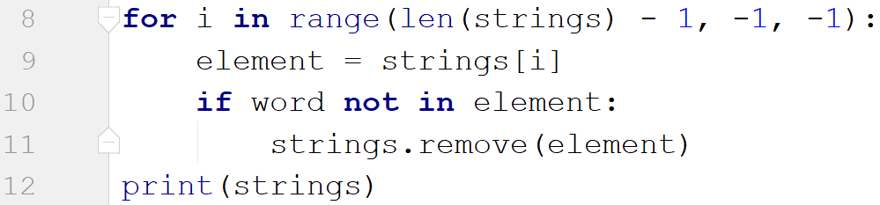

## Numbers Filter

On the first line, you will receive a single number **n**. On the following **n** lines, you will receive integers. After that, you will be given one of the following commands:

* even
* odd
* negative
* positive

Filter all the numbers that fit in the category (0 counts as a positive and even). Finally, print the result.

### Example

|  |  |
| --- | --- |
| **Input** | **Output** |
| 5  33  19  -2  18  998  even | [-2, 18, 998] |
| 3  111  -4  0  negative | [-4] |

### Hints

First, we read the number n. Then, we create the numbers list and the filtered list:

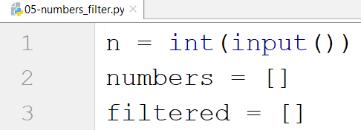

We create a loop that reads all the numbers and adds them to the list:

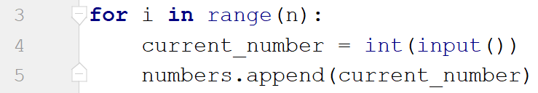

Then, we read the command and check for all the cases:

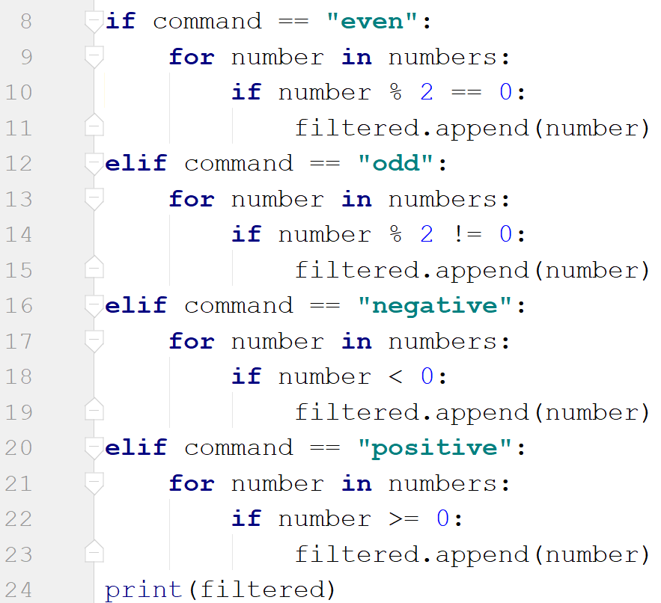

Finally, we print the filtered list.